Project Planning Phase
Project Planning Template (Product Backlog, Sprint Planning, Stories, Story points)

Date | 5 July 2026
Project Name | BOOK STORE
Maximum Marks | 5 Marks

Product Backlog, Sprint Schedule, and Estimation (4 Marks)
Sprint | Functional Requirement (Epic) | User Story Number | User Story / Task | Story Points | Priority | Team Members
Sprint-1 | Authentication | USN-1 | As a user, I can register and log in securely. | 3 | High | Venuthurumilli Thanuja
Sprint-1 | Authentication | USN-2 | As a user, I can access protected pages using JWT authentication. | 2 | High | Venuthurumilli Thanuja
Sprint-1 | Book Browsing | USN-3 | As a user, I can browse and view book details. | 3 | High | Venuthurumilli Thanuja
Sprint-1 | Search & Filter | USN-4 | As a user, I can search and filter books. | 3 | High | Venuthurumilli Thanuja
Sprint-2 | Shopping Cart | USN-5 | As a user, I can add, update, and remove books from the cart. | 3 | High | Venuthurumilli Thanuja
Sprint-2 | Checkout | USN-6 | As a user, I can enter shipping details and place an order. | 4 | High | Venuthurumilli Thanuja
Sprint-2 | Orders | USN-7 | As a user, I can view my orders and order status. | 3 | High | Venuthurumilli Thanuja
Sprint-2 | Reviews | USN-8 | As a user, I can add ratings and reviews to books. | 2 | Medium | Venuthurumilli Thanuja
Sprint-3 | Admin Dashboard | USN-9 | As an admin, I can view BookStore statistics. | 3 | Medium | Venuthurumilli Thanuja
Sprint-3 | Book Management | USN-10 | As an admin, I can add, update, and delete books. | 4 | High | Venuthurumilli Thanuja
Sprint-3 | Order Management | USN-11 | As an admin, I can view orders and update order status. | 3 | High | Venuthurumilli Thanuja
Sprint-3 | Management | USN-12 | As an admin, I can manage users and reviews. | 3 | Medium | Venuthurumilli Thanuja
Sprint-4 | UI & Responsiveness | USN-13 | As a user, I can use the application on mobile and desktop devices. | 3 | High | Venuthurumilli Thanuja
Sprint-4 | Testing | USN-14 | As a developer, I can test APIs and application functionality. | 3 | High | Venuthurumilli Thanuja
Sprint-4 | Optimization | USN-15 | As a developer, I can improve validation, error handling, and performance. | 3 | Medium | Venuthurumilli Thanuja
Sprint-4 | Deployment | USN-16 | As a developer, I can deploy the BookStore application. | 3 | High | Venuthurumilli Thanuja

Project Tracker, Velocity & Burndown Chart: (4 Marks)
Sprint | Total Story Points | Duration | Sprint Start Date | Sprint End Date (Planned) | Story Points Completed | Sprint Release Date (Actual)
Sprint-1 | 11 | 5 Days | 2 July 2026 | 6 July 2026 | 11 | 6 July 2026
Sprint-2 | 12 | 5 Days | 2 July 2026 | 6 July 2026 | 12 | 6 July 2026
Sprint-3 | 13 | 5 Days | 2 July 2026 | 6 July 2026 | 13 | 6 July 2026
Sprint-4 | 12 | 5 Days | 2 July 2026 | 6 July 2026 | 12 | 6 July 2026


Velocity:

Total Story Points Completed = 48
Number of Sprints = 4
Average Velocity = 48 / 4 = 12 Story Points per Sprint
The average project velocity is 12 story points per sprint, showing consistent progress across the four planned development sprints.
Burndown Chart:
A burn down chart is a graphical representation of work left to do versus time. It is often used in agile software development methodologies such as Scrum. However, burn down charts can be applied to any project containing measurable progress over time.
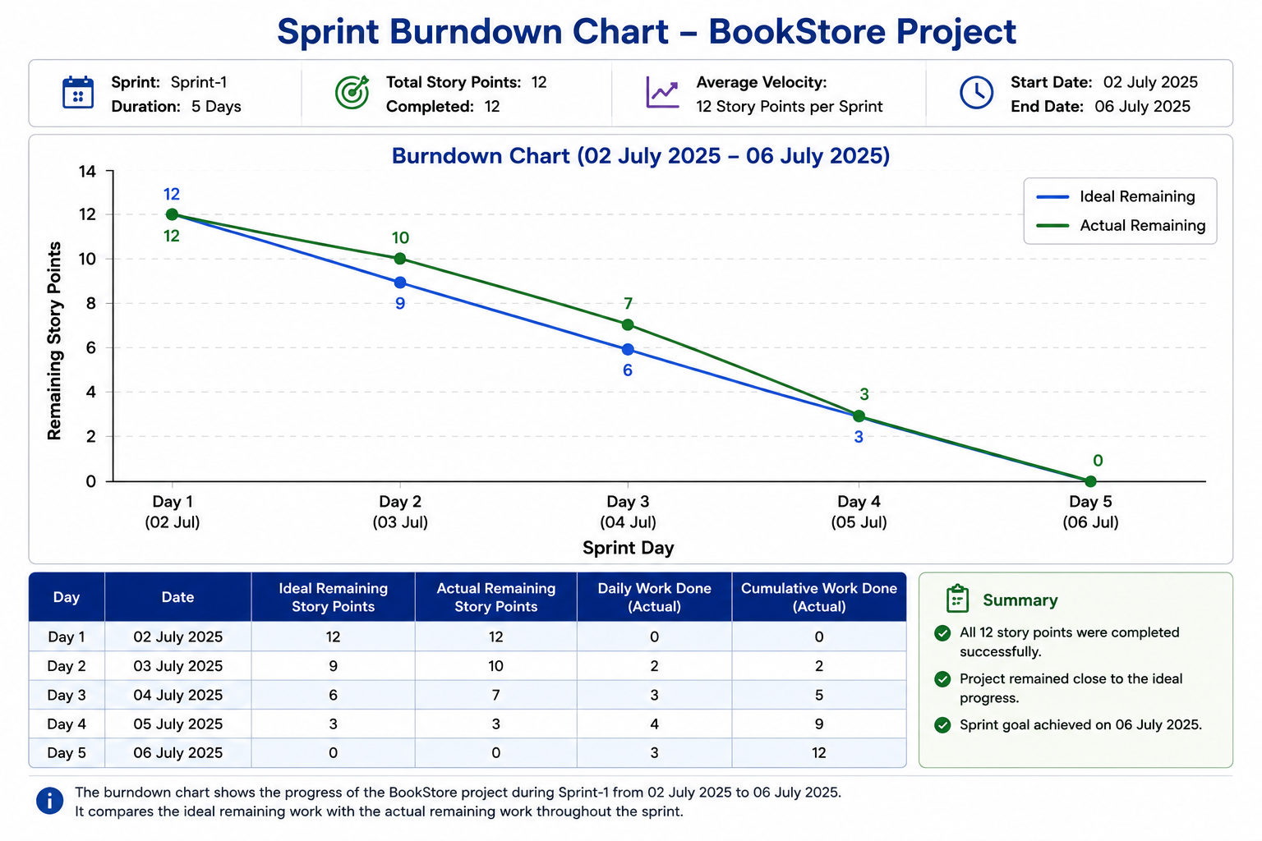

https://www.visual-paradigm.com/scrum/scrum-burndown-chart/
https://www.atlassian.com/agile/tutorials/burndown-charts

Reference:
https://www.atlassian.com/agile/project-management
https://www.atlassian.com/agile/tutorials/how-to-do-scrum-with-jira-software
https://www.atlassian.com/agile/tutorials/epics
https://www.atlassian.com/agile/tutorials/sprints
https://www.atlassian.com/agile/project-management/estimation
https://www.atlassian.com/agile/tutorials/burndown-charts

